Name: _________________Ben Pu__________________________
Lesson 5: Joins and Unions

- Join the film to the film_actor table.

SELECT * FROM film
FULL OUTER JOIN film_actor
ON film.film_id = film_actor.film_id

- Join the actor table to the film_actor table.

SELECT * FROM actor
FULL OUTER JOIN film_actor
ON actor.actor_id = film_actor.actor_id

- Try to join the actor, film_actor, and film table together (3 joins!)

SELECT * FROM film
LEFT JOIN film_actor
ON film.film_id = film_actor.film_id
FULL OUTER JOIN actor
ON actor.actor_id = film_actor.actor_id;

- Using the following Link https://github.com/niteen11/cuny_lagcc_micro_credential_data_analytics/tree/main/Track%20A/Unit%205%20-%20SQL_%20Relational%20Databases/guided%20exercise
And attached data set (Student_data and Student_marks ) answer the following questions :
-- students with the highest marks in Unit 4
SELECT unit4,student_id FROM student_marks ORDER BY unit4 DESC;
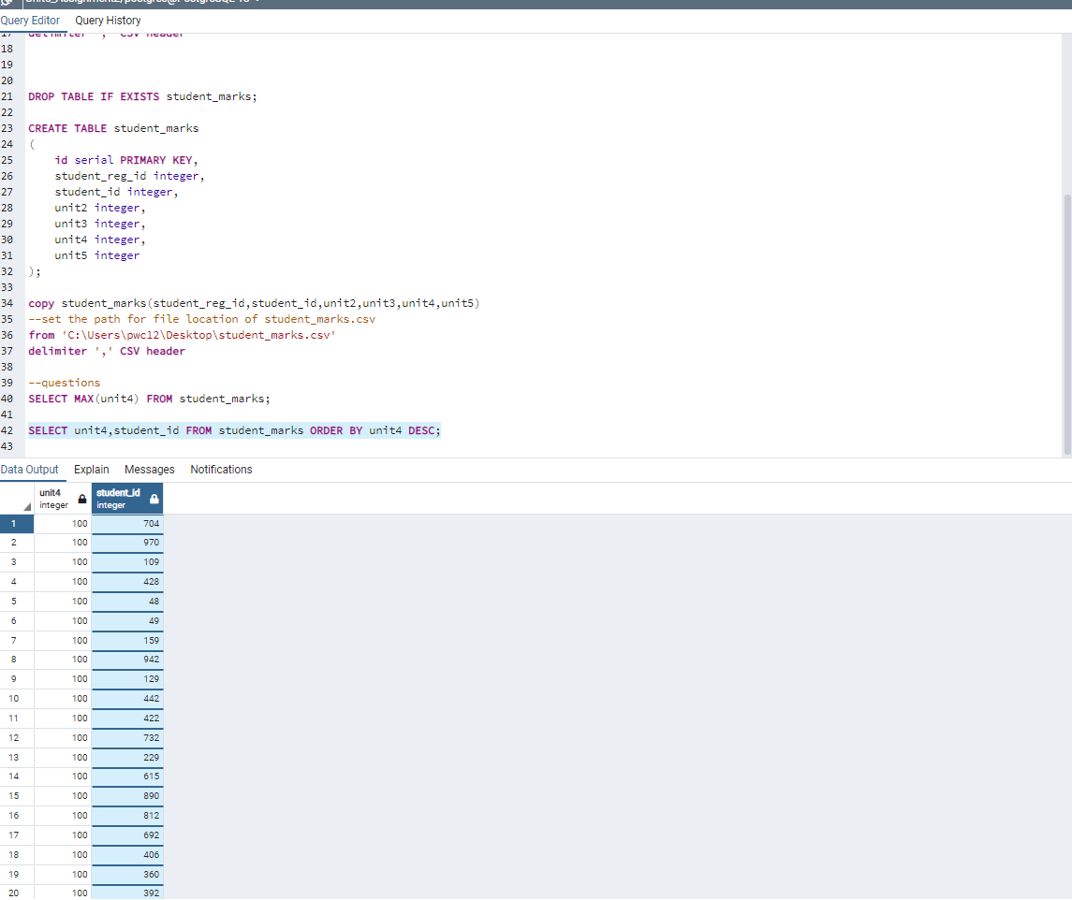

-- Find students scored between 89 and 100 unit4
SELECT * FROM student_marks WHERE unit4 BETWEEN 89 and 100;
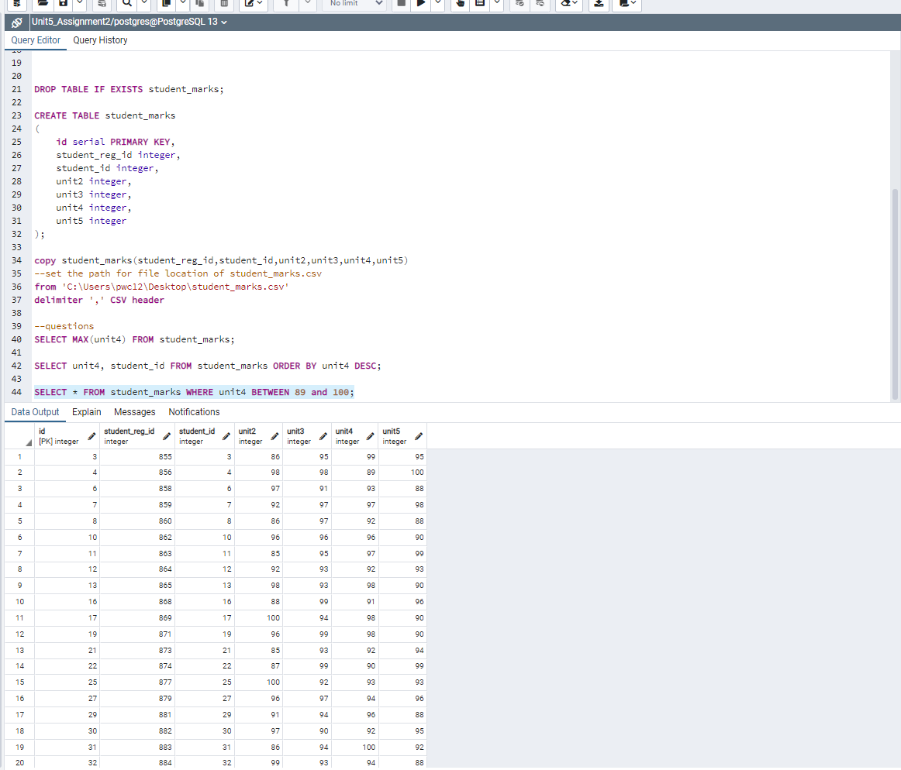

Open ended questions:
-- Take a closer look at the tables that you created and come up with 10 different scenarios/ questions and form SQL
-- Ask your colleagues

Different Scenarios:
- Be able to combine the two tables using the different join functions
- Who were the students that failed the unit1 exam? (less than 65)
- Which students failed unit2?
- Which students failed unit3?
- Which students failed unit4?
- Which students failed unit5?
- What was the average of each unit?
- Which unit had the highest average?
- Which individual students had the highest average throughout all of the units?
- Which gender did better throughout the units?

